Calculations

Table 1 : Constant Mass Difference

# | m₁ (g) | m₂ (g) | Δm (g) | a_{exp}(m / s²)  (rot mot sens) | a_{exp}(m / s²)  (mot sens) | a_{theo}(m / s²)
1 |  |  |  | -1.533 | 1.050 | 1.59
2 | 50.7 | 70.3 | 19.6 | -1.627 | 1.042 | 1.59
3 |  |  |  | -1.457 | 1.015 | 1.59
 |  |  | Mean | -1.539 | -1.035 | 1.59
4 |  |  |  | -1.971 | 1.336 | 1.90
5 | 40.7 | 60.3 | 19.6 | -1.965 | 1.376 | 1.90
6 |  |  |  | -1.983 | 1.248 | 1.90
 |  |  | Mean | -1.973 | 1.320 | 1.90
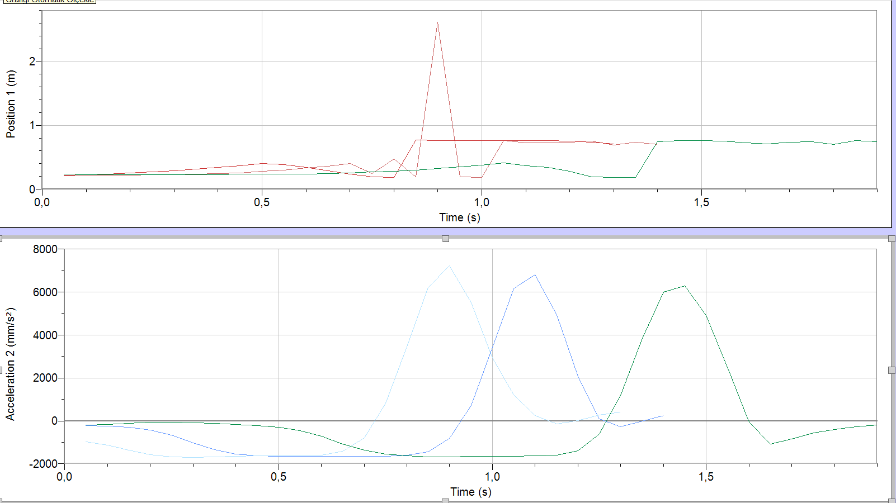
Graphs 1-2 : Position – Time and Acceleration – Time Graphs of Runs 1,2,3
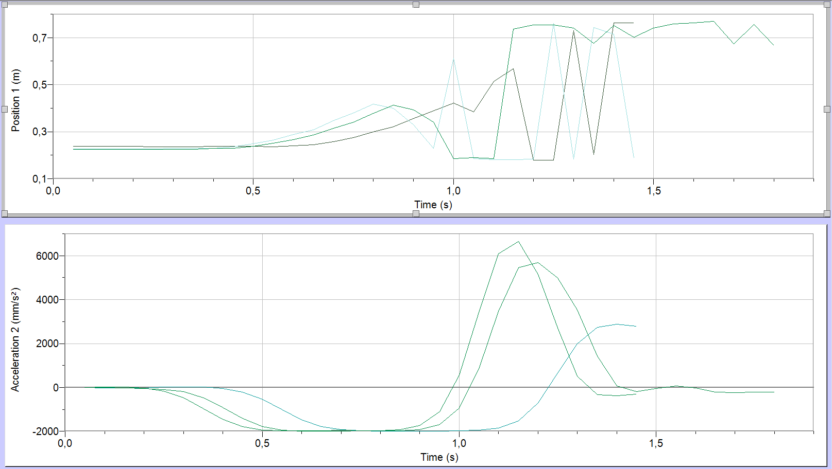
Graphs 3-4 : Position – Time and Acceleration – Time Graphs of Runs 4,5,6

Table 2 : Constant Total Mass
# | m₁ (g) | m₂ (g) | m₂ (g) | a_{exp}(m / s²)  (rot mot sens) | a_{exp}(m / s²)  (mot sens) | a_{theo}(m / s²)
1 |  |  |  | -2.435 | 1.245 | 2.37
2 | 30.7 | 50.3 | 81 | -2.501 | 1.046 | 2.37
3 |  |  |  | -2.410 | 0.925 | 2.37
 |  |  | Mean | -2.448 | 1.072 | 2.37
4 |  |  |  | -4.790 | 3.102 | 4.79
5 | 20.7 | 60.3 | 81 | -3.894 | 2.519 | 4.79
6 |  |  |  | -4.334 | 3.142 | 4.79
 |  |  | Mean | -4.339 | 2.921 | 4.79

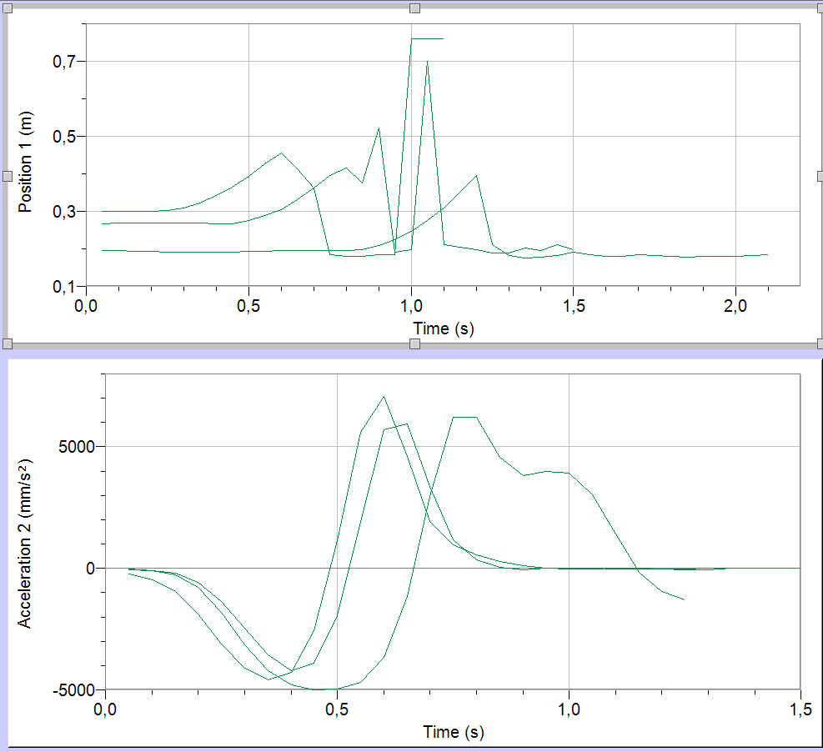
Graphs 5-6 : Position – Time and Acceleration – Time Graphs of Runs 7,8,9

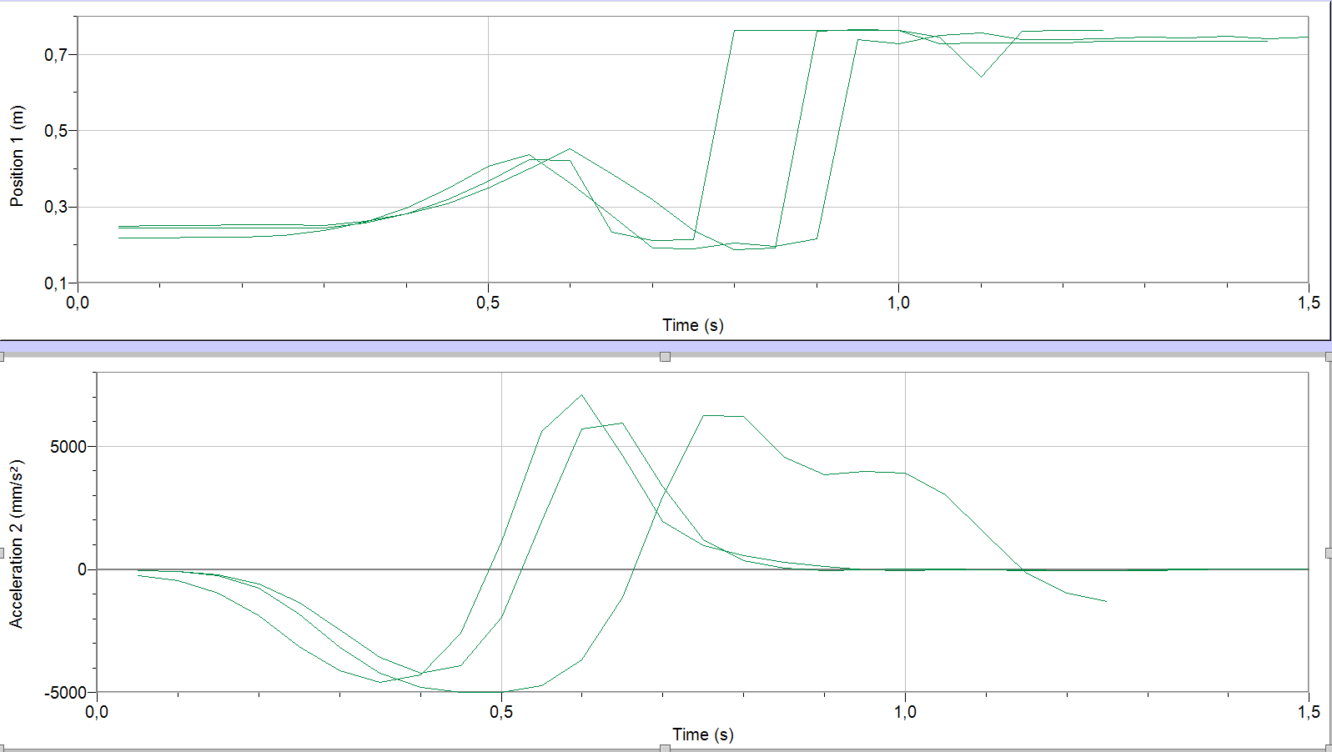
Graphs 7-8 : Position – Time and Acceleration – Time Graphs of Runs 10,11,12

Related Equations:
F_{net} = (m₁ - m₂) * g
m_{total} = m₁ + m₂
F_{net} = m_{total} * a
a = F_{net} / m_{total}
a = (m₁ - m₂) * g / (m₁ + m₂)

Calculations:
(70.3 – 50.7) * 9.8 / (70.3 + 50.7) = 1.59
(60.3 – 40.7) * 9.8 / (60.3 + 40.7) = 1.90
(50.3 – 30.7) * 9.8 / (50.3 + 30.7) = 2.37
(60.3 – 20.7) * 9.8 / (60.3 + 20.7) = 4.79

